# **FARMELY**

**Providing the best in agricultural solutions**.

**Our Team:**

**Abhinav Tiwari**

**Anirudh Sharma**

**Arijit Bhattacharjee**

**Rashi Sharma**

# **Table of Content**

**Table of Content …….……………………………………………………. 01**

**Team Collaboration Plan …….…………………………………………... 02**

Team Introduction……………………………….…….. 02

Project Charter…………………………………………. 04

Project Scope Statement………………………………. 05

**System Analysis……….………………………………………………….. 07**

                      System Requirements………………………………….. 07

                      Benchmarking…………………………………………. 10

                     Outcome Analysis**………………...................................** 12

                      Functional and Non-Functional Requirements**…………** 13 

**Project Structure……………………………………………………….... 15**

Project Plan……………………………………………... 15

Feasibility analyses……………………………………... 16

Organizational Feasibility………………………………. 17

Marketing Strategy……………………………………... 17

                     Economic Feasibility…………………………………… 17

                     Human resource management/staffing…………………. 09

**Interaction Diagrams……………………………………………………. 21**

Use Case Diagrams ……………………………………. 21

Use Case Descriptions………………………………….. 22 Activity Diagrams…………….…..……………………. 24

**System Structure Diagrams…………………………………………….. 26**

Class Diagram……………. …..………………………… 26

**Process and Behavior…………………………………………………… 27**

Sequence Diagram………………….…………………… 27

Behavioral Modelling…………………………………… 29

Communication & Behavioral based Diagram………….. 30

**Version 2.0 ……………………………………………………………… 32**

# **Team Introduction**

We at Farmely Pvt Ltd. aim to collaborate with farmers to provide them a solution for their farming problems which are hampering their growth economically, financially and personally. Our motive is to solve these problems by providing an information system solution for the same. We aim to build an app that will address most of the common issues faced by the farmers. Our primary focus is on farmers in India and we plan to launch this app locally in a village known as Punsari, Gujarat owing to its 24-hr Wi-Fi availability that would help farmers connect to our app.

**Team Member Details and roles:**

|  |  |  |  |
| --- | --- | --- | --- |
| Name | Phone Number | Email address | Roles |
| Abhinav Tiwari | 513-206-5993 | tiwariav@mail.uc.edu | Technical lead |
| Anirudh Sharma | 513-391-9029 | sharm3ad@mail.uc.edu | Project lead |
| Arijit Bhattacharjee | 513-485-2222 | bhattaai@mail.uc.edu | Technical Lead |
| Rashi Sharma | 513-546-0724 | sharmri@mail.uc.edu | Business Lead |

**Team Action Plan:**

1. The team will meet every Monday and Wednesday at Langsam Library to provide project status and discuss the future course of action. Minutes of meetings will be shared with the team to keep a track of upcoming activities and action assigned to a person.
2. Every team member has been assigned initial draft creation of one deliverable and a deadline for that has been pre-decided.
3. Deadlines for every document are fixed. It is expected from every team member to meet deadlines. If in a case, any team member is not able to deliver expected work then he/she should inform Project Lead. However, it is the responsibility of the complete team to deliver work on provided deadlines.
4. Review of the document is a must. An initial draft of document should be made by one team member and should be shared to all for review. Review comments should be documented for future references and should be cross-checked once incorporated.
5. Comments should be incorporated in the document with a new version. The standard followed is V. Number (starting from 1 and incrementing 1 every time). Every version should maintain a list of Reviewers who reviewed a document.
6. All documents made by the team should be placed in central repository Basecamp after reviewed by team members. Basecamp should be extensively used for scheduling, sharing and tracking purposes.
7. The Team will use the following medium for communication:

• WhatsApp/Phone/Text: This will be used to discuss project related queries in order to keep a track of all queries

• Email: It will be used to share Minutes of meetings where all details of the meeting will be kept

* Team Viewer: This will be used to simultaneously work on the deliverables if anybody is stuck somewhere

# **Project Charter**

**Title/name for the project:**

“Farmely”

**Short description of the problem:**

* Statistics show that the farmers in India do not salvage profits anywhere close to the viable amount as per their investment and suffer losses.
* Lack of adequate knowledge among farmers regarding the use of fertilizers, germicides and irrigation facilities.
* Lack of farmer’s connection with market forces them to sell their crops on whatever rate being offered to them.
* Farmers have the dearth of good logistics to supply their produce to the market and that is an issue that needs to be addressed.

**Value/benefit of the system:**

* Increased revenue to the farmer:

Farmers have a better platform to connect with customers They can compare market prices for their crop and choose whom to sell crops to (Vendors or Farmely). This will guarantee a better market price than what was offered earlier.

* Elimination of middleman:

Farmers are directly connected to market so unnecessary inclusion of middleman which increases the cost of products is removed. This benefit both farmers as well as vendors by giving profit directly to them instead of hierarchies involved in between.

* Training and knowledge:

Videos available in the app will impart proper training to farmers and help them in identifying solutions to questions like what seeds are best for their crop types, which pesticides/germicides to use, which fertilizer would be best for their soil.

**Primary audience/Consumer:**

Farmers, Vendors, Investors

# **Project Scope Statement**

|  |  |  |  |
| --- | --- | --- | --- |
| **Title:** | **Farmely** | **Date:** | September 10, 2018 |
| **Project Members** | Abhinav Tiwari, Anirudh Sharma, Arijit Bhattacharjee, Rashi Sharma | | |
| **Project Justification** | This project will increase farmers market reach. It will help in the better flow of income among farmers and, vendors and side by side will also help in increasing the company’s profit. | | |
| **Project Scope Description** | Farmely is a mobile app which targets Farmers and vendors. Farmers can choose the best price for their crops. They can tie up with Farmely to sell their crops or can sell crops directly to the vendor. Vendors must pay a certain amount to Farmely for enrolment. Farmers and vendors can communicate with Farmely executive for any kind of problem. | | |
| **Project Objective** | 1. To reduce farmer’s problem and presence of middlemen in between farming products and markets. Farmely aims to earn profit by making farmer’s efficient enough to generate good crop and increase the profit of company by directly buying from them. Also, Farmely allows vendors to join us in this initiative with nominal partnership fees. | | |
| **High Level Requirements** | * Increase in crop quality * Reduce middlemen intervention * Increase of crop price offer to the farmer * Increase in profit of Farmely * Giving better purchase price to vendors * User friendly system * Separate logins for farmers, vendors and executives | | |
| **In Scope** | * Login * View dashboard by farmers * View tutorials * Quote price * Contact / Answer helplines | | |
| **Out of Scope** | * Promoting the use of app to all states farmer’s * Offline use of application * Self-Registration of farmers | | |
| **Assumptions** | * The internet speed is good in the targeted area * The farmers are looking for a better way to sell their produce * The vendors are willing to provide competitive prices for the produce | | |
| **Deliverables** | A user-friendly app with three distinct login portals  (farmer, vendor, executive) | | |
| **Constraints** | Illiteracy among farmers and aloofness with technology | | |

# **System Requirements**

This section covers how we gathered information about the problem being faced by our target audience.

***Method for gathering information:***

* Observation
* Document analysis

***Reasons for choosing this method:***

* Farmers usually have a hectic lifestyle, whereby they do not have a lot of time to interact with people
* Since our target audience is based in India, in-person interaction was not possible
* Troubles faced by farmers in India is a very general issue and there are ample reliable documents and videos on the internet that elaborate the problem we are targeting

***Implementation of the method:***

We documented an article and a video interview related to the conditions of farmers which explain the problems faced amidst the current system. The gist of these articles and videos is a list of all the issues that we wish to eradicate with our project design.

*Sample 1:*

<https://www.bbc.com/news/world-asia-india-40184788>

This news article by [**BBC-India**](https://www.bbc.com/news/world/asia/india) was published on 8-June-2017, which happens to be very recent, indicating the problems we are targeting are still prevalent.

*Significant problems mentioned in the article and how Farmely targets them:*

* **Lack of access to good-quality seeds, manures and fertilizers due to high price and fragmented distribution:**

We at Farmely aim to provide farmers with the seeds and fertilizers at considerably low prices, after researching about what crops we want them to grow.

* **Unreliable rainfall leading to problems in irrigation and further in produce quantity and quality:**

Our research can provide us information about the general rainfall and water availability patterns in an area, so we can help farmers with deciding what crop should be grown in a particular region in a given time of the year for maximum possible productivity. We aim to do this via our learning videos and personal interaction if needed.

* **Lack of mechanical tools leading to degradation in work efficiency:**

Although we do not provide mechanical tools, we can connect the farmers to firms or organizations that sell farming tools at cheaper prices. That is more of a goodwill factor from our side, and not a part of our generic layout.

* **Poor condition of agricultural marketing leading to a deplorable economic condition for farmers, who are forced to sell at a price lower than anticipated:**

This is the most crucial point we aim to target. We provide farmers with very convenient quotations from our reliable vendors and link them to suitable external vendors if they do not wish to trade via Farmely directly.

**FIG:** Institutional credit to agriculture. Source: Accompanying article.

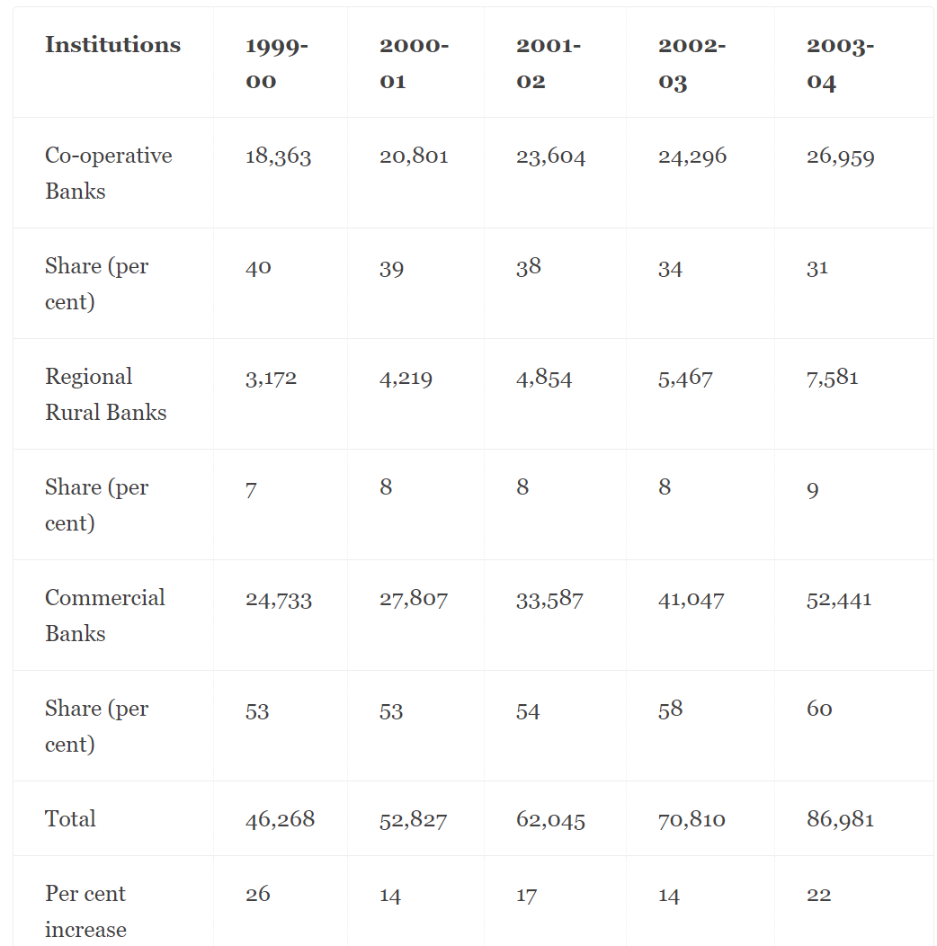

*Sample 2:*

<https://www.youtube.com/watch?v=P6LdpQH_Lno>



This video article by [**Zee News**](http://zeenews.india.com/)contrasts the stark differences between the living conditions of farmers in Bundelkhand, India and California, USA. The video is in Hindi language.

*Significant problems mentioned in the video and how Farmely targets them:*

* **A local politician approaches a locality of farmers to discuss their problems and ends up quarrelling with them instead of helping:**

As the name Farmely emphasizes, we aim to treat farmers like a part of our family, and ethical treatment and transparency with farmers remains the utmost important thing for our operation. We aim to eradicate the troubles of farmers, whether they be economical or ethical.

* **An American farmer explains how he has access to all kinds of pesticides and fertilizers, along with good quality seeds, which makes it very convenient:**

As our functionality covers, we provide our farmers with pesticides and good-quality seeds in order to increase the produce.

* **The Indian farmers hesitate from buying mechanical equipment and choose manual labor instead because they worry about falling in debt**

Our long-term aim is to uplift the general economic condition of the farming class. We hope that with time, the farmers might end up increasing their revenues and further having a better lifestyle, eventually being able to buy better equipment for their work.

**Benchmarking**

We undertook a study to compare the features of our mobile application with one of our potential competitors in the market.

|  |  |  |
| --- | --- | --- |
| **Feature** | **Farmely** | **LiveMint** |
| Separate Login Screen | Checkmark | Checkmark |
| Dashboards | Checkmark | Close |
| iOS and Android Version | Checkmark | Checkmark |
| Farmer-Vendor Connect | Checkmark | Close |
| Tutorials | Checkmark | Close |
| Predictive Models | Checkmark | Close |
| Payment Gateway | Checkmark | Checkmark |
| Helpline | Checkmark | Close |

**Outcome Analysis**

The end users require a system through which they can **effectively connect** with companies which will provide better financial value for their produce. They are also looking for opportunities where they can be better informed about the conditions which can improve their farm output and predict the upcoming revenue to a certain extent.

Our model has a phased approach which aims at **educating the farmers** about the model of the company and also about the app we have. The app will help improve the reachability of the organization’s services better to the farmers while also improving the farming practices via educational resources. In many cases it has been found that the farmers are unable to reach for help in case of adverse situations, the **helpline feature** in the app will also help address this issue.

**Functional Requirements**

|  |  |
| --- | --- |
| **NAME** | **REQUIREMENT** |
| **Login** | A registered user (Admin/Vendor/Farmer) should be allowed to log in with the correct combination of username and password.  New users should be allowed to register using new valid Email id (not present in the database) and password.  A password should between 6 to 20 characters and should not include the special characters # & + or space.  A user should be allowed to reset the password with “Forgot my password” link. |
| **View tutorials** | View tutorial link should only be displayed to farmers. No other user can see it.  Farmers should be allowed to select one link and link should direct the user to video exclusively made by Farmely executives.  If offline, error message should be displayed. |
| **View Dashboard** | Farmers should be allowed to see the quoted price for their crops.  Farmers should be able to compare the quoted price from the market price.  Farmers should be allowed to select vendor/Farmely who he wants to choose. |
| **Contact Helpdesk** | Farmers/Vendors should see a page with the helpline.  Farmers/Vendors should be able to place a class from that page. |
| **View crops** | Vendors/ Farmely should see what all crops are present in the system.  Vendors/Farmely should be able to send price. |

**Non-Functional Requirements**

|  |  |
| --- | --- |
| **NAME** | **REQUIREMENT** |
| **Usability** | An application should be user-friendly  Concise and complete error messages should be displayed in case of any error. |
| **Confidentiality:** | User’s password should never be displayed on a screen.  User password should be encrypted in the database.  Credit card details should be encrypted in the database. |
| **Access**  **Security:** | A user should be forced to change the password after the completion of “password expiration period”  A user should be allowed to view bookings made by only them.  Only authorized users should be allowed to make changes in the booking. |
| **Efficiency:** | At least 25 percent of the processor capacity and storage space available to the system shall be unused at peak load seasonal periods.  A system should be capable of booking at least 150 booking per sec. |
| **Maintainability** | The customer service call center should be responsive and analyze 95% of the problem reports within 2 hours.  Items classified as “Priority 1” shall be repaired within 2hrs of occurrence. Items classified as “Priority 2” should be resolved in 1 day. Items classified as “Priority 3” should be resolved in 3 working days.  The application development process must have a regression test procedure that allows complete re‐testing within 2 business days.  Only Database Administrator should be allowed to make changes in the production environment. |

# **Feasibility Analyses**

**Executive Summary:**

Farmely is an agro-based organization that aims at easing the life of farmers, by improving their income opportunities, while at the same time being economically feasible. In this, we will create an application where the farmers can sell their products to the firm directly at profitable rates or can directly sell it to the partnered vendors. We plan to help farmers in increasing their profitability. It also concentrates to educate the farmers free of cost about the best practices used in the industry.

**Technical Feasibility**

*The Categories of risks involved in the Farmely system:*

*Application/Website UI*: Farmers using the app/website for the first time may face some issues, but the Farmely representatives will provide small workshops in the villages to teach the farmers how to use the app. They will help farmer’s in loading crop details to the system. Also, the app is available in multiple languages and has very simple UI. Thus, the risk involved in this category is low.

*Technology Used*: might be certain low-level risks with the technology changes (technology becoming obsolete) and project migration. The technology used in the application and website is very generic and there is no shortage of experts of these technologies in the industry.

*Project Size*: This project starts with a limited number of employees, but as the project moves to its successive years the employees increase and thus can produce a moderate level of risk for the company, but as the project is financially stable (investors’ money) and we have checked the financial feasibility thus it will involve moderate level of risk.

*Educational Content and Spread:* This category might involve a low level of risk while providing farmers with educational content related to the crop production or app/website introduction manual content depending upon their region and the language that they speak.

*Managing and Coordination Staff and Funds:*  The management of interaction between the staff, farmers and vendors may cause a moderate level of risk, coordination between farmers and vendors, vendors and executives, farmers and executives depends indirectly upon the internet availability and the telecommunication network. All the proper measures are taken to manage funds from farmers and vendors.

**FIG:** Tabulation of Technical Feasibility

|  |  |  |  |
| --- | --- | --- | --- |
| **Category** | **Meaning** | **Example** | **Risk Level** |
| Application/Website UI | The application used is interactive and self-explanatory | The UI interface of our application is user-friendly and can be accessed in multiple languages | Low |
| Technology Used | The technology involved is generic and easy | The technology used is Oracle database, JavaScript, Java and, node.js which is easy to use | Low |
| Project Size | Large marketing and technical staff | The sales staff increases rapidly in the coming years | Moderate |
| Educational  Content and Spread | Creating  Interactive  educational content in multiple languages | The content available is present in multiple languages and is easy to understand, content creation outsourced when the project outreach will grow | Low |
| Managing and Coordination Staff and Funds | Managing the staff and coordination with farmers and vendors, and managing funds from the vendors and farmers | Managing the sales executives, vendors and farmers effectively | Moderate |

**Organizational Feasibility**

The project plan includes the proper organizational feasibility plan:

* The proper payment process is established for the employee salaries.
* Enough workforce is available for the successful implementation of the project.
* Enough funds are available (sponsors) for the successful implementation of the project.

**Marketing Strategy**

The marketing strategy includes:

* Collaboration with Gramin (Rural) Sabha to enroll more farmers in our scheme.
* The app will provide free educational content to the farmers depending upon the region/location they belong.
* The providing money to the farmers for their initial setup.
* Vendors will be provided cheaper rates than is offered currently.

**Economic Feasibility**

* This project is funded by the Adani Group, a budget of $1,80,000 is provided to our firm.
* There is a very low risk involved in the project as the budget allocated will easily accommodate the requirements of the venture.

**Intangible Benefit**

* Benefits include improvement of the social and economic condition of the farmers.

**FIG:** Tabulation of Economic Feasibility

|  |  |  |  |  |
| --- | --- | --- | --- | --- |
|  | **Year 1** | **Year 2** | **Year 3** | **Total** |
| **Benefits** |  |  |  |  |
| Software Download Sale | 10,000 | 70,000 | 3,00,000 |  |
| Vendor Profit | 12,500 | 1,05,000 | 5,80,000 |  |
| Farmer Profit | 15,000 | 87,000 | 3,05,000 |  |
| ***Total Sale*** | **37,000** | **3,62,000** | **11,85,000** | **1,584,000** |
|  |  |  |  |  |
| **Development Cost** |  |  |  |  |
| Infrastructure | 5,000 | 0 | 0 |  |
| Software | 10,000 | 0 | 0 |  |
| Hardware | 15,000 | 0 | 0 |  |
| ***Total Development Cost*** | **30,000** | **0** | **0** | **30,000** |
|  |  |  |  |  |
| ***Total Intangible Assets*** | **0** | **0** | **0** | **0** |
|  |  |  |  |  |
| **Operational Cost** |  |  |  |  |
| Office Lease | 20,000 | 20,000 | 20,000 |  |
| Labor | 1,00,000 | 1,50,000 | 5,00,000 |  |
| Marketing Expenses | 10,000 | 15,000 | 25,000 |  |
| Insurance | 2,500 | 10,000 | 20,000 |  |
| Ad-hoc Money to Farmers | 10,000 | 30,000 | 1,00,000 |  |
| ***Total Operational Cost*** | **1,42,500** | **2,25,000** | **6,65,000** | **10,32,500** |
|  |  |  |  |  |
| **Net Profit** | -1,35,500 | 1,37,000 | 5,20,000 | **5,21,500** |
| **Break Even Point** | **2 years** | | | |

# **Human Resource Management/Staffing/Collaboration plan**

**Core Team**

The core team consists of the main members who look after the business towers. It also depicts the responsibilities of each committee member.

|  |  |  |
| --- | --- | --- |
| **Role** | **Name** | **Responsibilities** |
| Business Lead | Rashi Sharma | 1.) finding new business opportunities  2.) managing investors fund  3.) Taking business decisions depending upon the business reports |
| Technical Lead | Abhinav Tiwari | 1.) managing project and tower budget 2.) providing the link between business and technical team |
| Technical Lead | Arijit Bhattacharjee | 1.) managing the quality of the deliverables(code) 2.) managing the testing and support functionality |
| Project Lead | Anirudh Sharma | 1.) looking after the project flow  2.) managing the project staff 3.) to ensure project delivery on time |

**Staffing**

The staffing plans include the staff related to the respective functionality. The project has front-end developer, backend developer, testing team, business analyst, executives/representatives. It also consists of content writers which develop educational material.

|  |  |  |  |
| --- | --- | --- | --- |
| **Functionality** | **Designation** | **Responsibility** | **No of Associates** |
| **Technical** | Front End Developer | To develop the UI of the application | 2 |
|  | Back End Developer | To maintain the database of the application | 2 |
|  | Testers | To perform unit, functionality  and sanity application | 2 |
|  | Data Architect | Creating the framework of the application | 1 |
| **Business** | Business Analyst | Solving business problems by providing technical solutions | 1 |
| **Helpline** | Customer Service Associate | Provide 24/7 help to vendors and farmers | 4 |

**Use-Case diagram**



Farmely Mobile App

FARMER



EXECUTIVE



VENDOR

`

# **Use-Case Descriptions**

|  |  |  |  |  |  |  |
| --- | --- | --- | --- | --- | --- | --- |
| **ID:** 1 | **NAME: BUY/SELL CROPS** | | | **IMPORTANCE:** CRITICAL | | |
| **PRIMARY ACTORS:** FARMER, VENDOR, EXECUTIVE | | | | **USE CASE TYPE:** PRIMARY FUNCTIONALITY | | |
| **FUNCTIONALITY (FARMER)**  -Selling crops to the vendor after acknowledging a quotation -Receiving payments | | | **FUNCTIONALITY (VENDOR)**  - Making a deal with farmer about the quotation and buying the crops - Making payments | | **FUNCTIONALITY (EXECUTIVE)**  - Monitoring the transaction  - Resolving conflicts that arise | |
| **PRE-CONDITIONS:** The farmer and vendor must be on an accord about the selling prices | | | | **POST-CONDITIONS:**  Quotations of prices by vendors, and choosing of a desired vendor by the farmer | | |
| **FREQUENCY:**  VERY HIGH | | **EXCEPTIONS:** If the farmer chooses to go with a vendor outside the organization, this use case would not be called. | | **INCLUDES:** Payment options. | | **ASSUMPTIONS:** Farmer and vendor have mutually decided a suitable price without conflict. |
| **NORMAL COURSE OF EVENTS:**  - The user (Farmer, Vendor or Executive) logs onto the system  - The vendor can quote prices and connect with the farmer  -The farmer checks the quotation and decides to proceed with the sale or not  -The vendor makes the payment after deciding to buy - The executive can logon to monitor the ongoing activities as well as cater to the helpline complaints | | | | **NOTES AND ISSUES:**  -- Price quotations are provided by vendors, and the farmers have a choice to compare the proposed prices with external market  - The executives monitor the whole process to make sure conflicts of interest do not arise, and both the parties are on the same page. | | |
|

|  |  |  |  |  |  |  |
| --- | --- | --- | --- | --- | --- | --- |
| **ID:** 2 | **NAME: QUOTE/COMPARE PRICES** | | | **IMPORTANCE:** HIGH | | |
| **PRIMARY ACTORS:** FARMER, VENDOR, EXECUTIVE | | | | **USE CASE TYPE:** MULTI-USER INTERACTION | | |
| **FUNCTIONALITY (FARMER)**  - Comparing prices with market prices  - Deciding whether to link with vendors on Farmely or not. | | | **FUNCTIONALITY (VENDOR)** - Quoting prices for farmers - Making and receiving payments - Contacting Helpline | | **FUNCTIONALITY (EXECUTIVE)** - Overlooking interactions between farmers and executives -Overlooking transactions and giving a command to keep a record. | |
| **PRE-CONDITIONS:** The farmer must be willing to interact with a vendor to listen to his/her quoted price.  The vendor must be ready with a quote. | | | | **POST-CONDITIONS:**  The farmer must decide about choosing the Farmely vendor or not.  The executive has to overlook the deal if made. | | |
| **FREQUENCY:**  SIGNIFICANT | | **EXCEPTIONS:** NONE | | **INCLUDES:** Quotations and monitoring | | **ASSUMPTIONS:** The farmers and vendors both have accounts on the app, and are willing to interact. |
| **NORMAL COURSE OF EVENTS:**  - The farmer logs onto the system and views a quotation provided by vendor for his harvest - The vendor logs in to provide this quote, which is made visible to the farmer.  -The farmer can decide to pursue the vendor, or bargain based on the quotation.  -If the farmer chooses not to proceed, we break the link with the vendor and connect him to external vendors. - The executive can logon to monitor the ongoing activities as well as cater to the helpline complaints | | | | **NOTES AND ISSUES:**  - The quotations are provided by vendors and viewed by farmers. The timings can sometimes precede each other, so both the farmer and executive should be encouraged to frequently log on the app.  -The executives must be active to view any discrepancies in the deals, monetary or other. | | |
|

**Activity Diagrams**

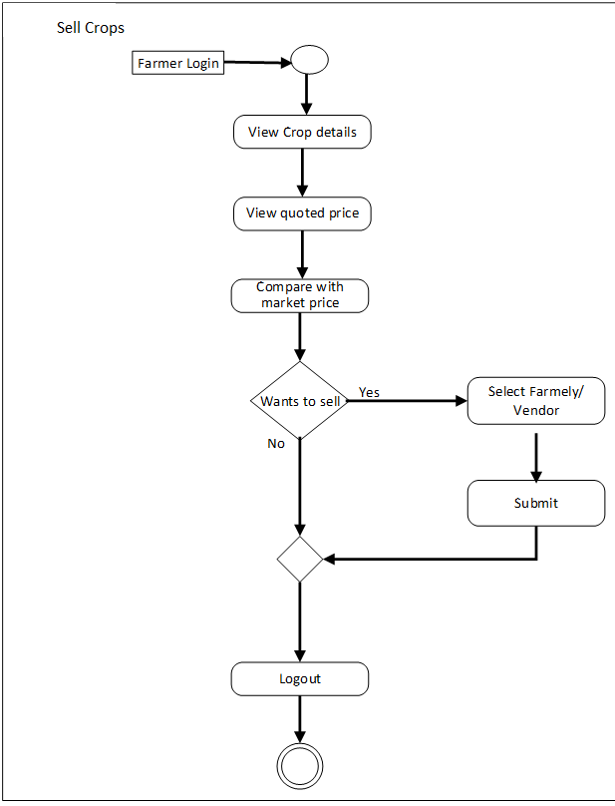



**Class Diagram**

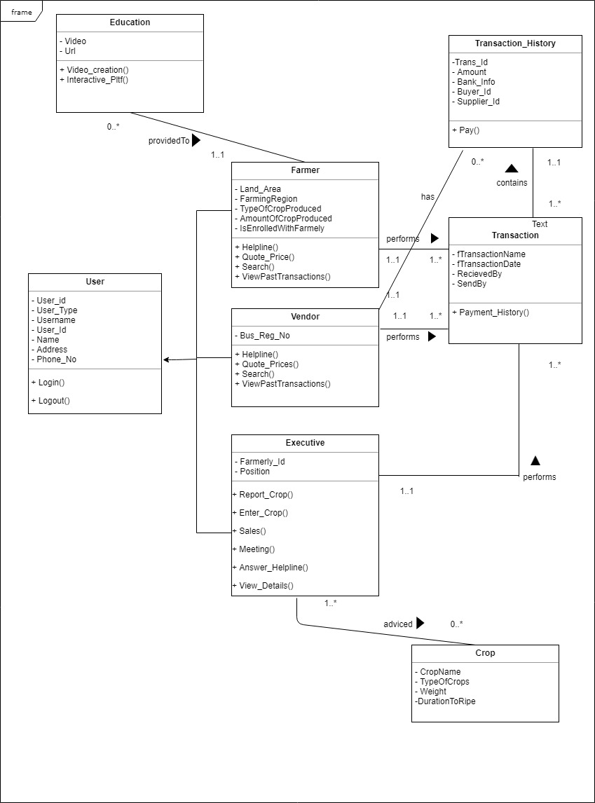

**Sequence Diagrams**

**FIG:** Quote Prices sequence



**FIG:** Sell Crops sequence



**State behavioral Diagram**



**Communication Diagrams**





**Version 2.0**

In the second phase of the Farmely we plan to focus on the following things:

1) Increasing the customer base

2) Providing insurance coverage for crops

3) Establishing offsite centers

4) Collaboration with third-party vendors for getting cheap farming equipment

We aim to increase the customer base of our application. We want to target regions other than Punsari so that we can curb farmer’s problem there also. This will also help in increasing the profit of Farmely. We also want to use advertising strategies (online, tv-ads etc.) in the second part of the project to increase our customer base.

Secondly, we will collaborate with insurance companies to provide insurance coverage of the crops from natural calamities like flood, drought etc. A farmer will be entitled to this insurance when he gets enrolled with Farmely scheme.

Thirdly, Farmely aims to conquer the market by establishing physical offices to provide physical support centers to farmers. In this way, we can help them better and be available to help them readily. This will also help us to attract more farmers to get in our scheme.

Lastly, we plan to expand our horizons in the field of farming equipment and will collaborate with 0ithird-party vendors to get seeds, fertilizers, and other farming equipment and make it available to farmers at the cheaper rates than there in the market. This will help them to grow good quality crops at a cheaper price.

-EOD-